In this lab we will create a new version of Cart app and will use direct deploy from source option for cloud run

1. Go to vscode and open cart folder, go to file named Index.cshtml umder pages and add “from code” in line 13. This will distinguish our new version and show that this version was deployed directly from code  
     
   A screen shot of a computer

   AI-generated content may be incorrect.
2. Run code locally by pressing F5 and this should open cart webpage with new version i.e. from code  
   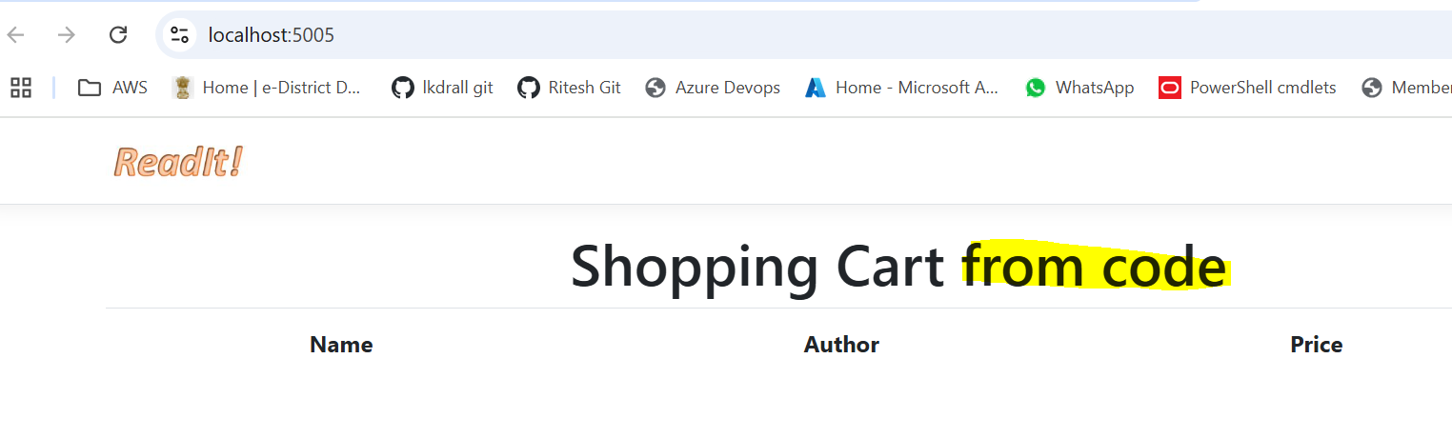
3. Go back to the VScode and we can stop the running, the open the terminal
4. Run below command  
   gcloud run deploy cart -–source .  
   Note, here –source . means to run it right from the folder where we are now  
   A screenshot of a computer

   AI-generated content may be incorrect.
5. When it ask for region, give the same region which we used in previous lab and then Y  
   A screenshot of a computer program

   AI-generated content may be incorrect.
6. Once completed successfully, go to gcp console again, refresh page and under revisions now you will see an another version created. Note that now all traffic is going to the newer deployment  
   A screenshot of a computer

   AI-generated content may be incorrect.
7. Click at the link again and now it should open the new version, which is from code  
   A close up of a sign

   AI-generated content may be incorrect.
8. Go to manage traffic, here we can explore options about managing traffic between different version (no need to change anything, only check options)  
   A screenshot of a computer

   AI-generated content may be incorrect.
9. Go to Artifactory page, there will see a new repository is created with same name as we discussed in theory part. Open this repo and you will see a cart docker image there. It was automatically created during this deployment as we discussed in behind the scenes part of deploy from source  
   A screenshot of a computer

   AI-generated content may be incorrect.
10. Now go to vscode and open cloud run (gcp cloud) option from vscode, here under cloud run we can see the cart details we just deployed via vscode, from here as well we can check the details of the instance created by this deployment  
    A screenshot of a computer

    AI-generated content may be incorrect.